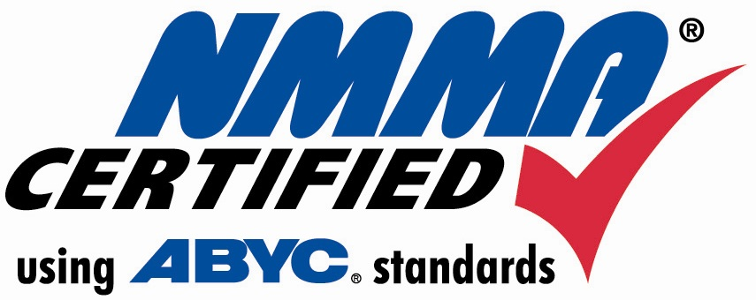
SCHEDULE B
This schedule is to provide the guidelines that apply to the use of certification labels that are issued by NMMA in connection with its certification programs. NMMA issues certification labels directly to manufacturers as a part of these programs. This schedule sets forth the guidelines that apply to the use of those labels while in the manufacturer’s possession.
- Most importantly, NMMA Certification labels must be placed only on boats that meet certification requirements of NMMA. The Certification Agreement with NMMA provides that NMMA labels are to be placed only on boats that meet these requirements. Placing these labels on boats that do not meet these requirements or on any other product or item is a violation of the Agreement. Please review the Agreement for details.
- Certification labels can be ordered by following the instructions issued by the NMMA Fulfillment Department. When procuring labels, please make sure the most recent label price list is used as well as the current master model listing model number.
- Certification labels should be ordered only in amounts needed for the current model year. The NMMA reserves the right to refuse to issue certification labels in excess of a manufacturer’s current model year needs. At the end of the model year, excess capacity labels should be destroyed.
- Certification labels cannot be reproduced under any circumstances. The labels include trademarks registered to NMMA and cannot be used or reproduced without prior written approval from NMMA. Labels can be procured only by placing an order with NMMA. You may not obtain additional labels through reproduction of labels in your possession.
- The proper use of certification labels is the responsibility of the manufacturer. Appropriate measures shall be made to ensure that certification labels are used only for their intended purpose. Measures shall also be made to ensure that labels are never placed on boats that do not meet NMMA certification requirements, or on other marine products; never provide labels to other manufacturers or to any other individual or entity.
- NMMA labels and plates are printed in accordance with 33CFR183 and ABYC S-7, and incorporate materials rated for marine use using strict material and performance specifications.
- If you become aware of a situation where NMMA certification labels have been improperly used, please contact NMMA directly.
- Manufacturers of Inflatable boats have the option to print the logo directly on the boat with the capacity information. To do so, the manufacturer must pay NMMA a licensing fee of $0.10 per unit, payable to NMMA quarterly by the 30th day of the month following the close of each calendar quarter. NMMA must be notified in writing by any inflatable manufacturer wishing to exercise this option. NMMA will provide express written permission granting such licensing right upon receipt and review of the manufacturer’s request.
Adherence to this schedule is necessary to ensure that only those boats that meet NMMA requirements are provided with certification labels. Please be aware that NMMA reserves the right to modify these guidelines or to implement new guidelines within its sole discretion. Additional guidelines may be provided to you from time to time. Questions concerning these guidelines can be directed to NMMA at 312.946.6200.

