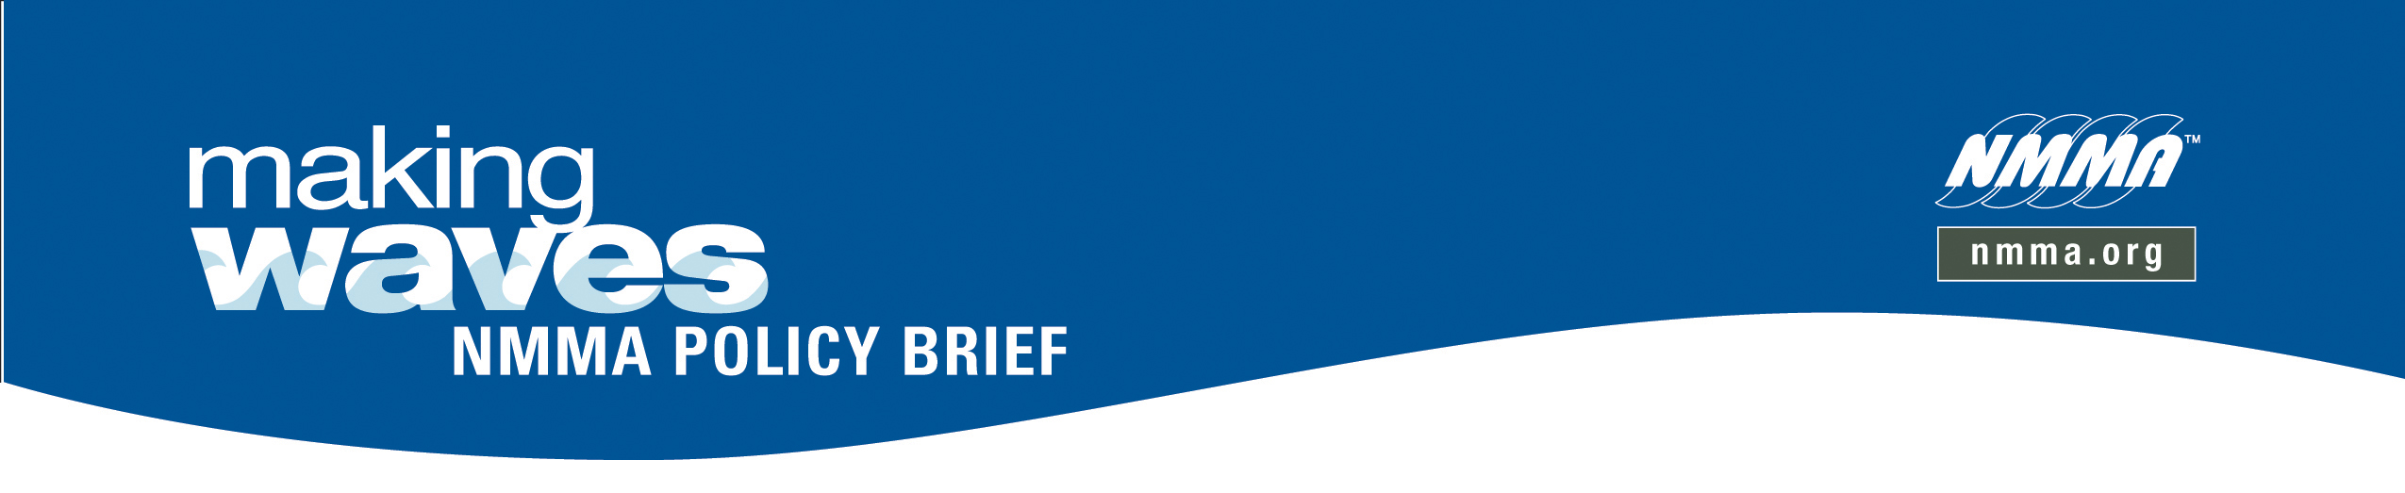

Louisiana Boat Commission Considers Anti-competitive Legislative Agenda
THE PROBLEM:
The Louisiana Recreational and Used Motor Vehicle Commission (LRUMVC) is currently developing its legislative agenda for 2009. The agenda is a list of changes to current law that the commission will ask the legislature to consider when its session opens on April 27, 2009.

Two legislative changes under consideration are of significant concern to NMMA members.

The repeal the “opting out of jurisdiction” provision and the 21 day notice for marine disputes in R.S. 32:785.
The proposal would remove the current right of marine dealers and manufacturers in dispute over possible violations to have these legal cases heard by a court of law. NMMA objects to the proposal because these legal disputes are of significant importance to the parties involved. They often require complex presentations from both parties that require significant time and resources from the presiding court or the commission. Given these complexities, the litigants should continue to have this option. Litigants should continue to be able to consider a court of competent jurisdiction in East Baton Rouge Parish as the entity most able to devote the time and resources to collecting, hearing and deciding particularly difficult disputes. In addition, the staff recommendation is a wholesale repeal of R.S. 32:785, which would removed the commission’s exiting right to compel the production of records and papers, subpoena witnesses and depose persons. The proposal submitted by the LRMVA staff also replaces the 21-day notice requirement for hearings before the commission with a 15-day notice. A 15-day notice places an undue burden on out-of-state manufacturers who must arrange travel and prepare to present their case in Baton Rouge.

Revisions to R.S. 32:816: Manufacturer mandatory repurchase of inventory
- The revisions to R.S. 32:816 to include marine and RV products would require a manufacturer to buy back a dealer’s inventory in all instances regardless its age, with the only exception being a successful appeal to the commission challenging the dealers’ decision to drop a brand. This statutory mandate places all risk for inventory management and good business practices upon the manufacturer. As an example of the imbalance that would be created by this proposal, a marine dealer facing bankruptcy could, with minimal foresight, force a manufacturer to repurchase his entire inventory of boats and parts on hand simply by cancelling or not renewing his contract with a manufacturer. The revisions even absolve the dealer of responsibility to segregate the items to be repurchased from his regular inventory. The balance of risk is further tipped to favor marine dealers by requiring the manufacturer to buy back inventory when a dealer simply stops selling boats. The staff-proposed changes also allow a dealer to drop one brand in favor of another, knowing that the exiting brand manufacturer will be required to buy back and remove any unsold inventory within 60 days. These mandates provide the dealer, at his choice, either a “get-out-of-debt free” card in the case of business failure, a government-provided white knight to rescue him from parts and vessel inventory mismanagement, or government-mandated protection from the fiscal impact associated with a dealer voluntarily dropping one brand in favor of another.
- The buy-back of inventory is intended to apply to vessels for sale in “new” condition. The proposal would require a manufacturer to repurchase inventory with damages totaling as much as 20 percent of the value of the boat. Damages totaling 20 percent of the value of a vessel is an unacceptable standard to determine “new” condition, regardless of whether the cost to repair the damage is deducted from the buy-back price. The average unit cost of a boat in the U.S. market is $35,486. The staff’s proposed changes to R.S.32:816 would require a manufacturer to buy back a vessel with damages totaling as much as $6,972. Given that the purpose of the commission is to regulate the marine industry so as to protect the consumer, it should oppose any legislative agenda that would encourage the sale of refurbished boats to the public as if they are in “brand new” condition.

THE IMPACT:
Unless the staff-proposed legislative agenda is rejected by the commission, NMMA will vigorously oppose its adoption in the 2009 legislative session. Should the changes be implemented, the costs and risks of selling boats to dealers in the state will significantly increase. Manufacturers continuing to sell into the state will face the likelihood of mandatory inventory buybacks from dealers who are experiencing economic hardship or who are expecting to exit the industry altogether.

THE SOLUTION:
NMMA and its members must strongly oppose the staff-recommended legislative agenda with members of the LRUMVC. Model letters will be posted on this Louisiana site within days. An appeal to all NMMA marine manufacturers will follow the posting of the model letter, with a request that the letter be sent to the LRUMVC.

