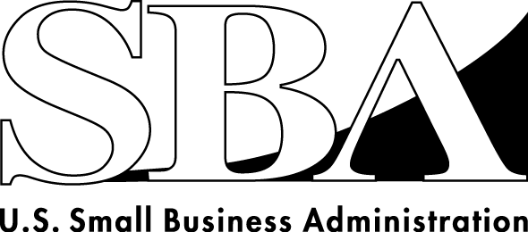 News Release
PRESS OFFICE

Release Date: May 28, 2009 | Contact: Hayley Matz (202) 205-6948
Release Number: 09-37 | Internet Address: http://www.sba.gov/news

SBA Will Offer Floor Plan Financing to
Auto, RV, Other Dealerships Beginning July 1

KOKOMO, IND. – The U.S. Small Business Administration will offer government guaranteed loans to finance inventory for eligible auto, recreational vehicle, boat and other dealerships under a new pilot program announced today by SBA Administrator Karen Mills.

Dealer Floor Plan (DFP) financing will be available beginning July 1, according to Mills. She announced the new program during a visit to Kokomo, Ind., with Dr. Ed Montgomery, President Barack Obama’s Director of Recovery for Auto Communities and Workers.

“Countless small businesses, including dealerships, across the country are facing significant challenges as a result of the uncertainty in the auto industry,” Mills said. “Floor plan financing can offer some dealerships the opportunity to get through these tough economic times by allowing them to keep their inventory and cash flow intact, as well as save the jobs these small businesses provide.”

Mills and Montgomery discussed the new DFP pilot program, as well as other resources offered by SBA and the federal government to help small businesses in communities impacted by the troubles facing the auto industry.

“Small businesses are the engine of our economic growth,” Dr. Montgomery said. “We are committed to finding ways the federal government can cut through red tape and get resources to these companies quickly during these tough economic times. From supporting nearly $4 billion in lending to small businesses across the country since February to the Dealer Floor Plan financing announced today, the SBA is making the resources provided in the Recovery Act accessible and working to provided needed credit. The President is committed to continuing to work with federal officials to identify resources like these that make a real difference in the lives of our auto communities and workers.”

Floor plan financing is a line of credit that allows dealers to borrow against their inventory, and then repay that debt as they sell their inventory or borrow against the line of credit again to add new inventory.

Under the DFP pilot program, the SBA will provide loan guarantees for lines of credit through its 7(a) program. DFP loans will be made through SBA lenders only for titled inventory, including autos, RVs, manufactured homes, boats and motorcycles. The pilot program will begin July 1 and will be available through Sept. 30, 2010, at which time the SBA will make the determination of whether or not to extend the program.

DFP loans will be available for a minimum of $500,000 up to the $2 million allowable under the 7(a) program. With a maximum repayment term of five years, the loans will come with a 75 percent government guarantee. Borrowers will also benefit from the temporary elimination of fees on 7(a) loans made possible by the America’s Recovery and Reinvestment Act of 2009.

During a roundtable discussion later in the afternoon with local small business owners Mills provided information on other SBA loan programs and benefits provided by the Recovery Act. Specifically, small business owners can take advantage of higher government guarantees on some 7(a) loans, as well as reduced fees on both 7(a) and 504 loans. The agency is also providing more tools to help small businesses compete for federal government contracts, along with technical assistance and counseling for business owners and entrepreneurs to help them deal with the economic challenges they face.

“We are committed to being the real partner small businesses need at this critical time,” Mills said. “Floor plan financing is just the latest tool in our toolbox to help small businesses in communities like Kokomo weather this recession and drive our nation’s economic recovery.”

# # #

